**PROJECT REPORT TEMPLATE**

1. **INTRODUCTION** 
   1. OVERVIEW

Wholesaling or distributing is the sale of goods to retailer to industrial, commercial, institutional or other professional businessman to other wholesalers (wholesale businesses) and related subordinated services. Wholesaling is buying goods in bulk quantity, usually directly from the manufacturer or source, at a discounted rate. The retailer then sells the goods to the end consumer at a higher price making a profit.

* 1. **PURPOSE**

The use of the wholesale market is to know the consumption and production of marketed food are spatially separated. Production is primarily in rural areas while consumption is mainly in urban areas. In today’s highly competitive business landscape, gaining deep market insights is essential for businesses to thrive and grow. This project helps us to analyze customer spending behavior and identify many opportunities for growth by leveraging data analytics and data-driven decision-making.

1. **PROBLEM DEFINITION AND DESIGN THINKING** 
   1. 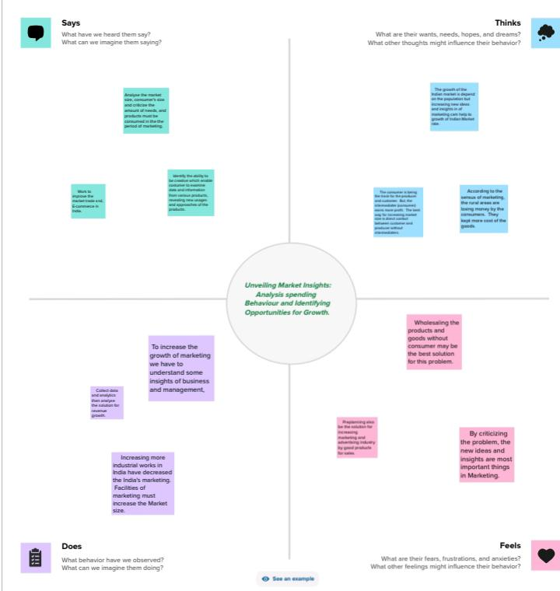EMPATHYMAP

**2.1 IDEATION AND BRAIN STORMING MAPPING**

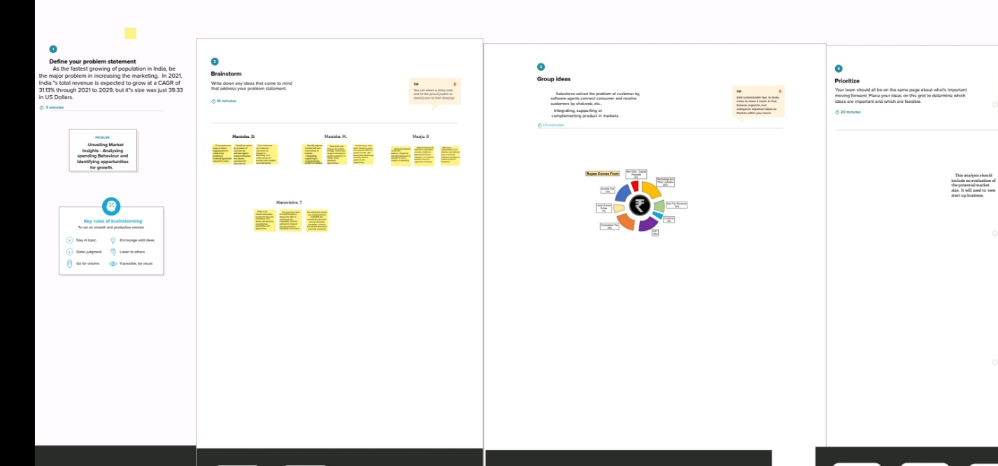

1. 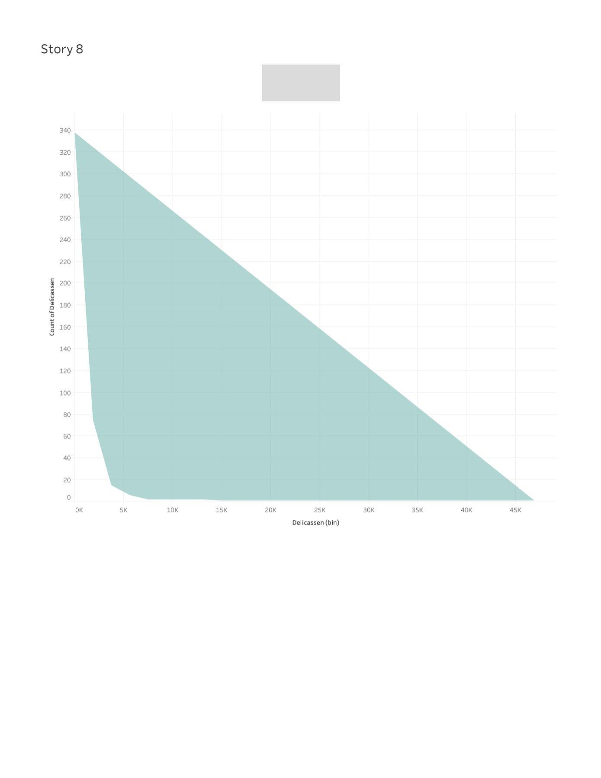**RESULTS**

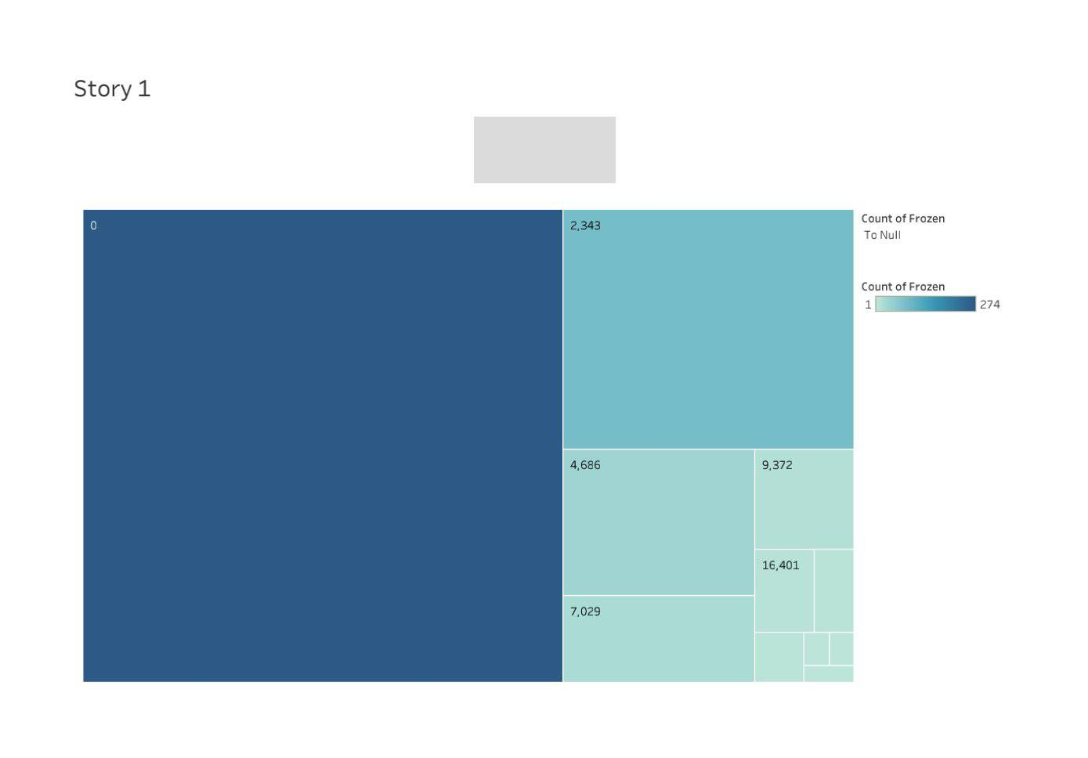

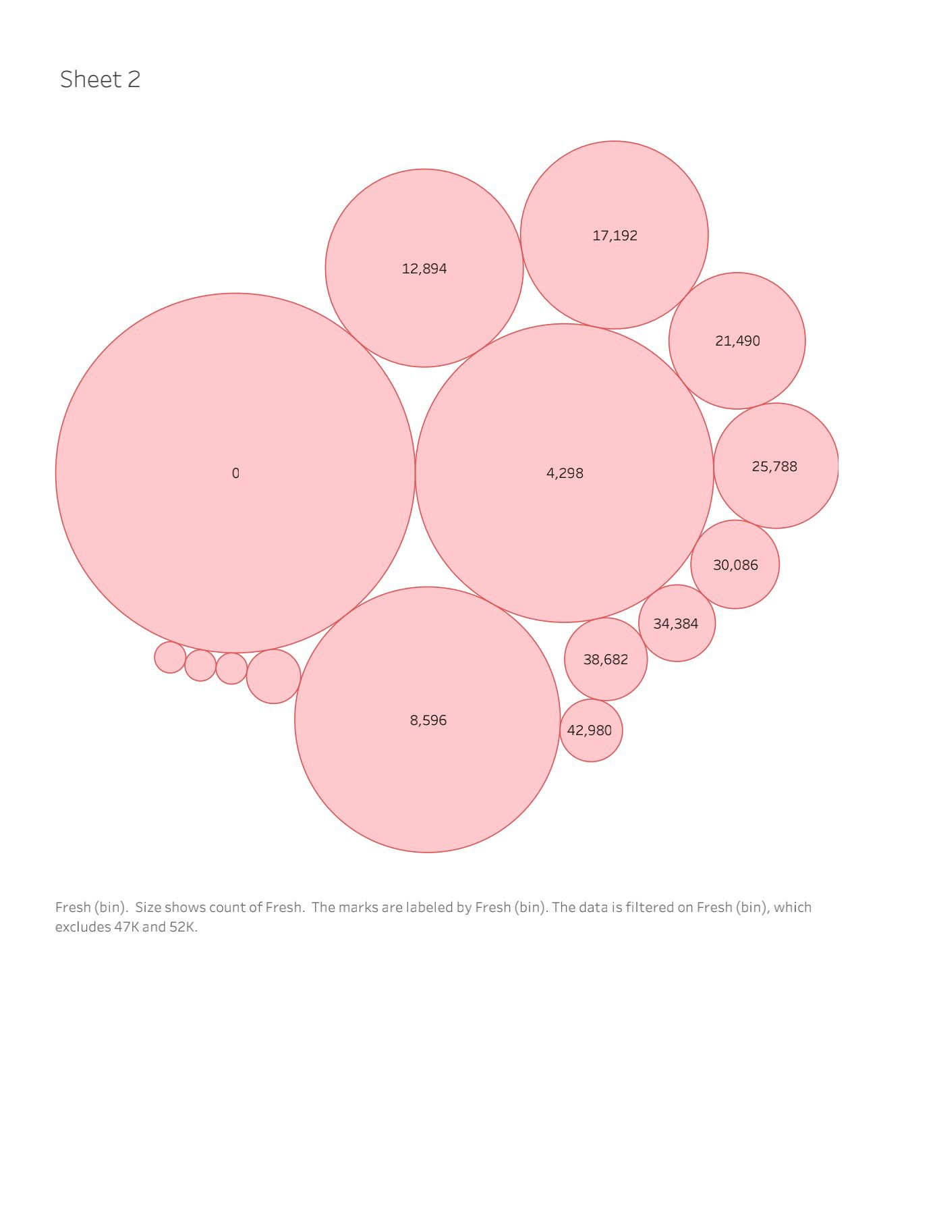

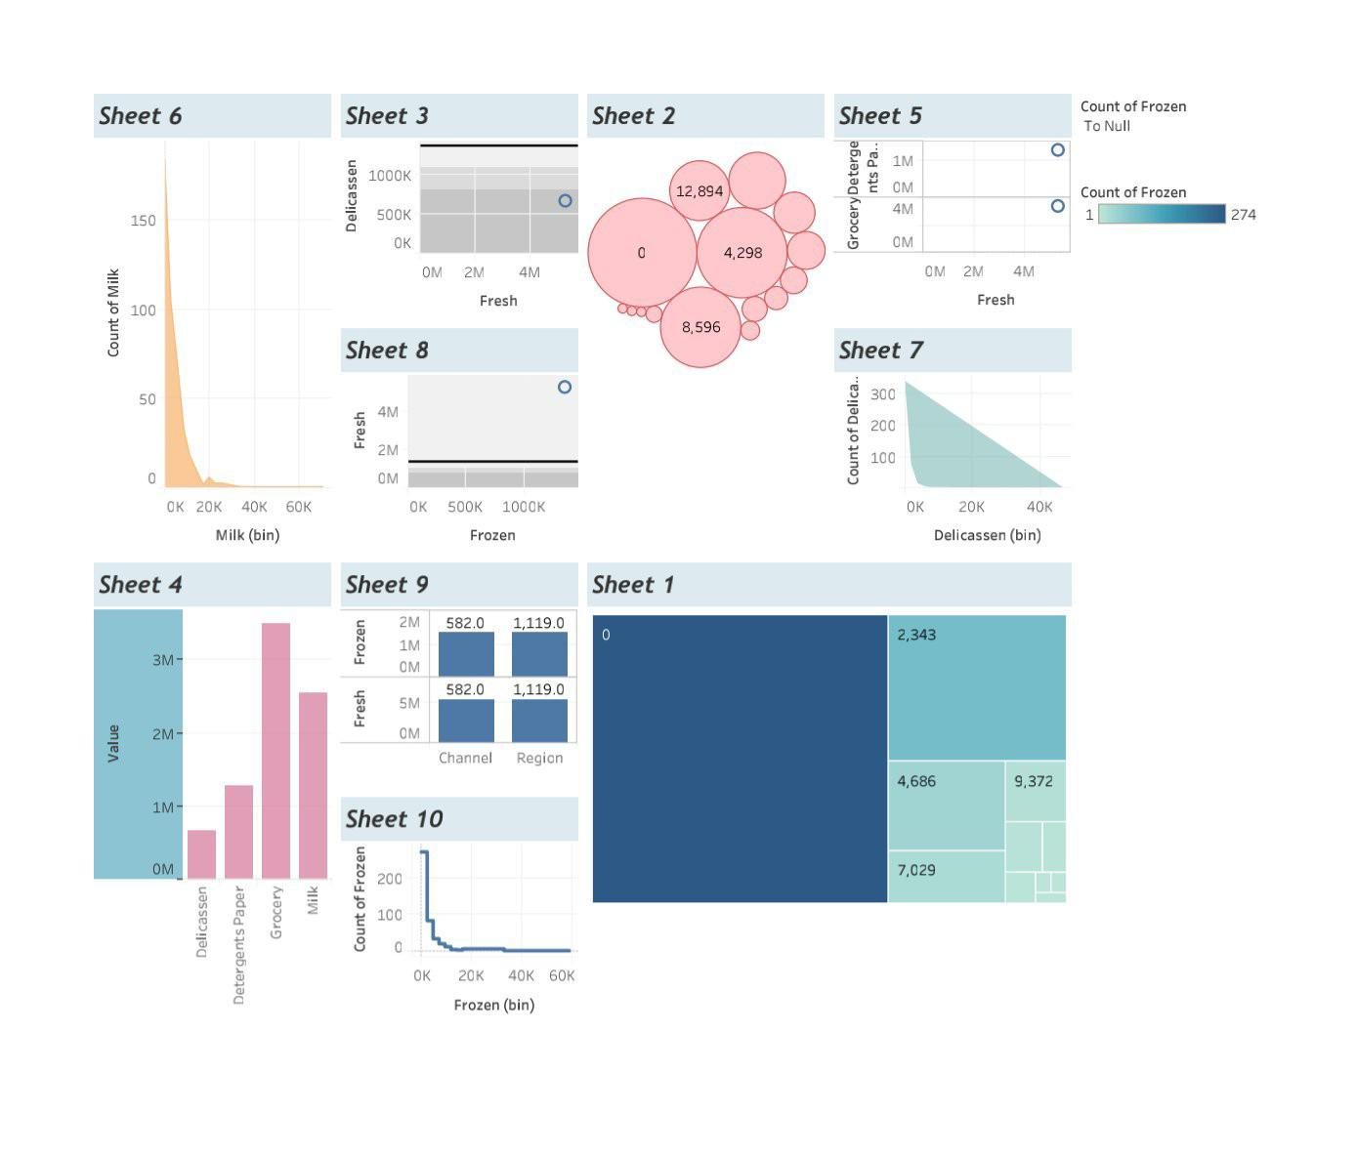

* By using the dataset we can analyze the wholesale prices and conclude that in Rural areas we can trade a direct marketing to get the gain.
* Then we can learn the vizzes and to publish the wholesale products using TABLEAU.

1. **ADVANTAGES AND DISADVANTAGES**

**ADVANTAGES**

* We can know about the business insights and the marketing trades.
* We can analyse the data about the WHOLE SALE PRODUCTS AND SOLUTIONS of the problem of Business.
* We can learn about the decision making about the major problems and issues in Marketing, Business and Management etc. ,

**DISADVANTAGES :**

* Sometimes it’s hard to find out the solution for marketing in Some places.
* It’s complexity to find the difference between rural areas and urban areas marketing.

1. **APPLICATIONS**

* The areas where the solution has been solved is Rural areas., because many of the people in rural are illiterate and uncivilized so they will not get any knowledge about the Marketing.

1. **CONCLUSIONS**

The consumption and production of marketed food are spatially separated. Production is primarily in rural areas while consumption is mainly in urban areas. In today’s highly competitive business landscape, gaining deep market insights is essential for businesses to thrive and grow. This project aims to analyze customer spending behavior and identify opportunities for growth by leveraging data analytics and data-driven decision-making. The primary objective of this project is to understand customer spending patterns, preferences, and trends across various dimensions.. By conducting a comprehensive analysis, businesses can optimize their marketing strategies, improve product offerings, and enhance customer engagement to drive revenue growth.

1. **ENHANCEMENTS**

* Get more knowledge about Analytics
* Learn more about Data literacy
* Get well in advanced level of skills in visualisation.
* Improve the performance of team works
* Use to maintain and manage the organisation
* Helps us to best in works in companies

1. **APPENDIX** 
   * 1. **Source Code**

https://github.com/asanm22322321201044/Unveiling_-Market_Insights_NM2023TMID10359/tree/main